

| Name of Student | Arthur Leonard LESMANA | ID | 18780 |
| --- | --- | --- | --- |

**Assessment 1 – Case Study**



**Contents**

Instruction: 2

Duration: 2

Case Study: 2

Going Green application, Green IT Project Management 2

Project profile 2

Here is my software running on my phone! Or Access by: 4

Business situation 4

Your tasks: 5

Task 1: Identify Business Strategy and Gap 5

Analyse Strategy 5

Task 2: Recommend a feasible solution 6

Task 3: Produce a Project Charter 6

Task 4: Project Document 8

Task 5: Project Closure 9

Helpful web links to complete the assessment: 12

Search Index 13

## Instruction:

This task is to be completed individually. You need to analyse a case scenario and complete all the tasks mentioned after the scenario.

You need to demonstrate your IT project management ability to identify business strategy and gaps. You will also need to suggest a feasible solution to overcome identified gaps and produce a project charter along with a WBS to implement the proposed solution.

### Duration:

Trainer will set the duration of the assessment.

**All my works could be opened in:** [**https://arthleo.github.io/pmarthur18780/**](https://arthleo.github.io/pmarthur18780/)

## Case Study:

### Going Green application, Green IT Project Management

# Project profile

Going “Green” is a mission of many companies around the globe not just for reasons of environmental responsibility, but also for cutting costs in these extremely tight economic times. Green IT efforts represent a specific focus area within enterprises that hold attention to this trend. Green IT leverages information technology to streamline operations, cut costly waste, and reduce the impact on the environment. IT typically consumes only about 10% of an organization’s energy costs, but the net effect of a Green IT project is to go beyond just energy saving. To tackle the other 90%, a Green IT project extends into a variety of other departments, and to execute such an endeavour requires an effective project management function in order to identify and prioritize goals. A Green IT transformation can be a complex process.

Vital Statistics:

* Number of project tasks - 12
* Project duration - 16 months
* Project budget - $1,200,000
* Number of users - 50

**I use Google Sheets to make Gantt Chart instead of Ms. Project Software, I use Sir John’s reference which is very simple to follow:**

<https://docs.google.com/spreadsheets/d/1FKGZUtobBdEyA22cImz176jYuQU68G9CBRHwJqLayPA/edit?usp=sharing>

**And this is my Gantt Chart Google Sheets link:**

[**https://docs.google.com/spreadsheets/d/18PuwJ7gfSPf-d5Q7Mw0aNGt9jH1qbbZdgsUOxPIbb_Q/edit?usp=sharing**](https://docs.google.com/spreadsheets/d/18PuwJ7gfSPf-d5Q7Mw0aNGt9jH1qbbZdgsUOxPIbb_Q/edit?usp=sharing)

[Gantt Chart PM](https://docs.google.com/spreadsheets/d/18PuwJ7gfSPf-d5Q7Mw0aNGt9jH1qbbZdgsUOxPIbb_Q/edit?usp=sharing)

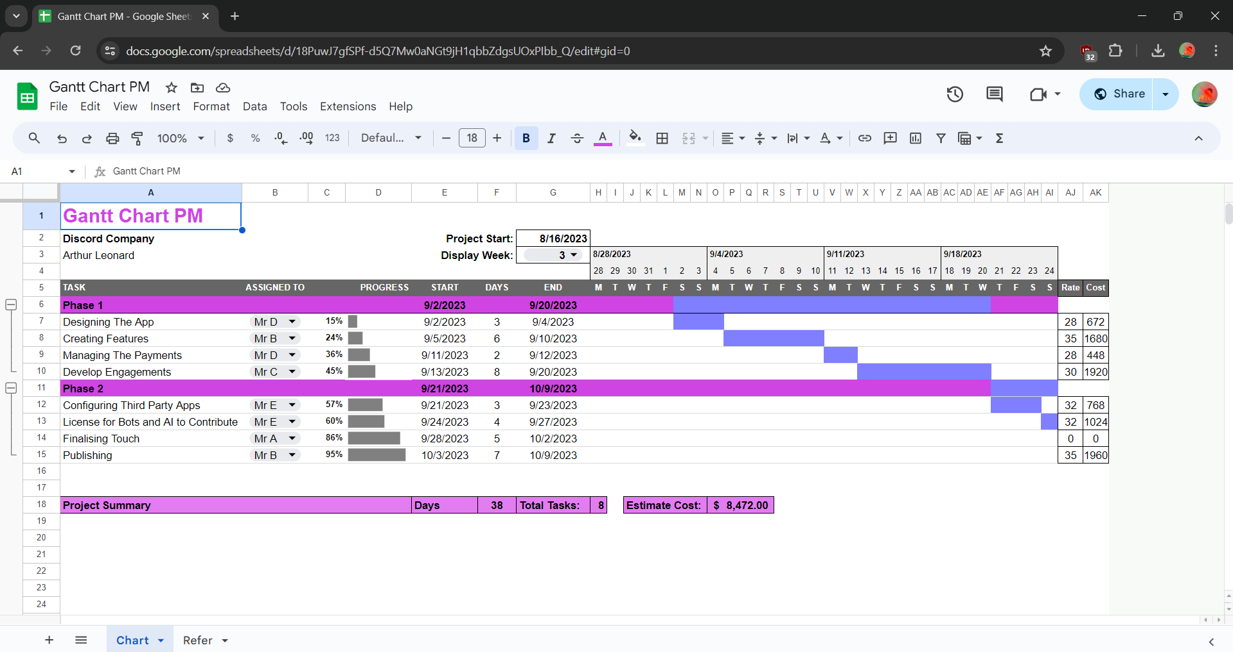

**Basic Tutorial Reference could be found in this link:** [**https://www.youtube.com/watch?v=8eKk0M2zGIk**](https://www.youtube.com/watch?v=8eKk0M2zGIk)

### Business situation

**Sample Summary Report:**

**The successful opening of a Discord company requires careful planning, execution, and ongoing management. By following the outlined tasks and timeline, the company can establish a strong presence on Discord and build a thriving community.**

**This summary report provides a high-level overview of the process, with the Gantt chart offering a visual representation of the timeline for each task. Adjustments can be made to the specific tasks and durations based on the company's goals and resources.**

## Your tasks:

### Task 1: Identify Business Strategy and Gap

Document the business’s strategies of “Green IT” and also summarise the components required changes for the participating organisation to implement “Green IT Project”. (Min. 300 words)

Business strategy is a planning function of any organisation. Business strategy incorporates having a strategic plan.

**I will be documenting my own Business Strategies which is “ Discord Company Project “. 👍**

### Analyse Strategy

**A project is a temporary initiative undertaken to achieve a specific goal. It has a predetermined start and end date and is distinct from normal business operations. Projects are governed by the triple constraint of time, scope, and cost. Project management involves skills in project management, people and workflow management, and strategy and leadership. The project manager is accountable for the project's success and must make decisions and take action to ensure the project stays on track.**

**📈 Projects can be triggered by various factors, such as market needs, business needs, technological advancements, customer requests, legal requirements, social needs, and ecological considerations. These triggers create demands for projects and determine their priority.**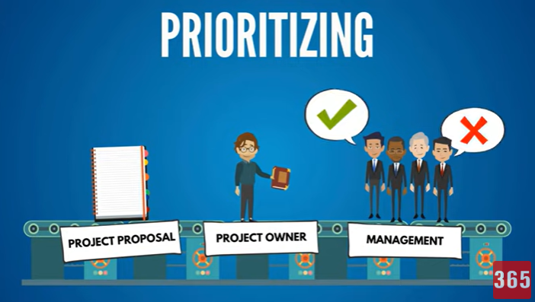

### Task 2: Recommend a feasible solution

**The project manager plays a critical role in ensuring project success. They are accountable for the project's achievement of its specific goal within the constraints of time, scope, and cost. Project managers must possess a diverse set of skills, knowledge, and expertise to effectively lead and manage projects.**

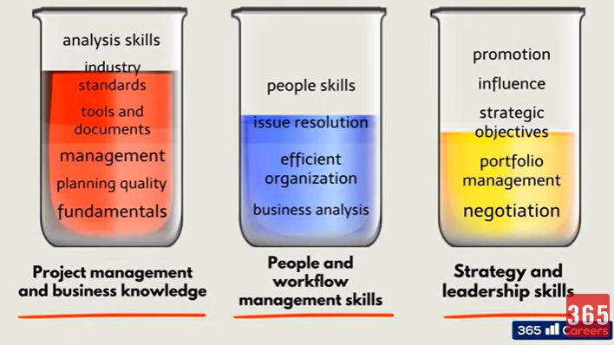

**See above simple example.**

### Task 3: Produce a Project Charter

Please view my project charter (here only show part):

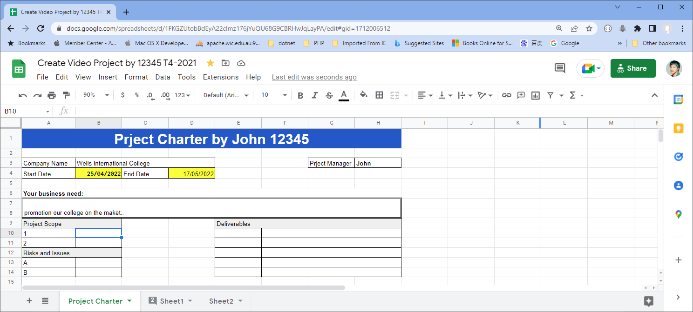

Develop a project charter for the Windsor project specifying project start date, finish date, approximate budget, project manager, project team with roles and responsibilities, project objective, project approach and stakeholders.

**Name: Discord Company Project**

**Description: Opening a platform for communities and make their very own servers**

**Manager: Arthur Leonard**

**Date Approved: May 6, 2024.**

**Project Start Date: May 15, 2024**

**Project Finish Date: July 30, 2024**

**Approximate Budget: $500,000**

**Project Team:**

| 1. **Project Manager** | **Responsibilities: Overall project oversight, communication with stakeholders, resource allocation, risk management.** | **Arthur Leonard** |
| --- | --- | --- |
| 1. **Software Development Team** | **Responsibilities: Developing and implementing new features, ensuring platform stability and scalability.** | **Kurosaki Ichigo**  **Son Goku**  **Gon Freecs** |
| 1. **UX/UI Design Team** | **Responsibilities: Designing intuitive user interfaces, improving user experience.** | **Yuji Itadori**  **Satoru Gojo** |
| 1. **Quality Assurance Team** | **Responsibilities: Testing the platform for bugs and issues, ensuring high-quality deliverables.** | **Maki Zenin**  **Toji Fushiguro** |

**Project Objective:**

**The objective of the Discord Company Project is to enhance the existing Discord platform by implementing new features, improving user experience, and ensuring platform stability. This project aims to solidify Discord's position as a leading communication platform for communities, gamers, and businesses.**

**Project Approach:**

1. **Analysis and Planning: Conduct a thorough analysis of user feedback, market trends, and technological advancements. Develop a detailed project plan outlining tasks, timelines, and resource requirements.**
2. **Development and Implementation: Execute the planned development tasks including feature enhancements, UI/UX improvements, and backend optimizations. Utilize agile methodologies to adapt to changing requirements and ensure timely delivery.**
3. **Testing and Quality Assurance: Implement rigorous testing procedures to identify and resolve any bugs or issues. Conduct user acceptance testing to ensure that the new features meet user expectations and quality standards.**
4. **Deployment and Monitoring: Deploy the updated platform in phases, closely monitoring performance and user feedback. Implement necessary adjustments and updates based on user response and performance metrics.**

**Stakeholders:**

1. **Internal Stakeholders:**

* **Project Team Members**
* **Senior Management**
* **Development and Operations Teams**

1. **External Stakeholders:**

* **Discord Users**
* **Investors**
* **Third-party Developers**
* **Business Partners**

1. **Key Partners:**

* **Technology Providers**
* **User Experience Consultants**
* **Marketing Agencies**

1. **Regulatory Bodies:**

* **Compliance Agencies**
* **Data Protection Authorities**

**This project charter outlines the scope, objectives, approach, and key stakeholders of the Discord Company Project. It serves as a reference document to guide the project team throughout the project lifecycle.**

### Task 4: Project Document

**Please check my site:** [**https://arthleo.github.io/pmarthur18780/**](https://arthleo.github.io/pmarthur18780/)

Please replace the images by yours below:

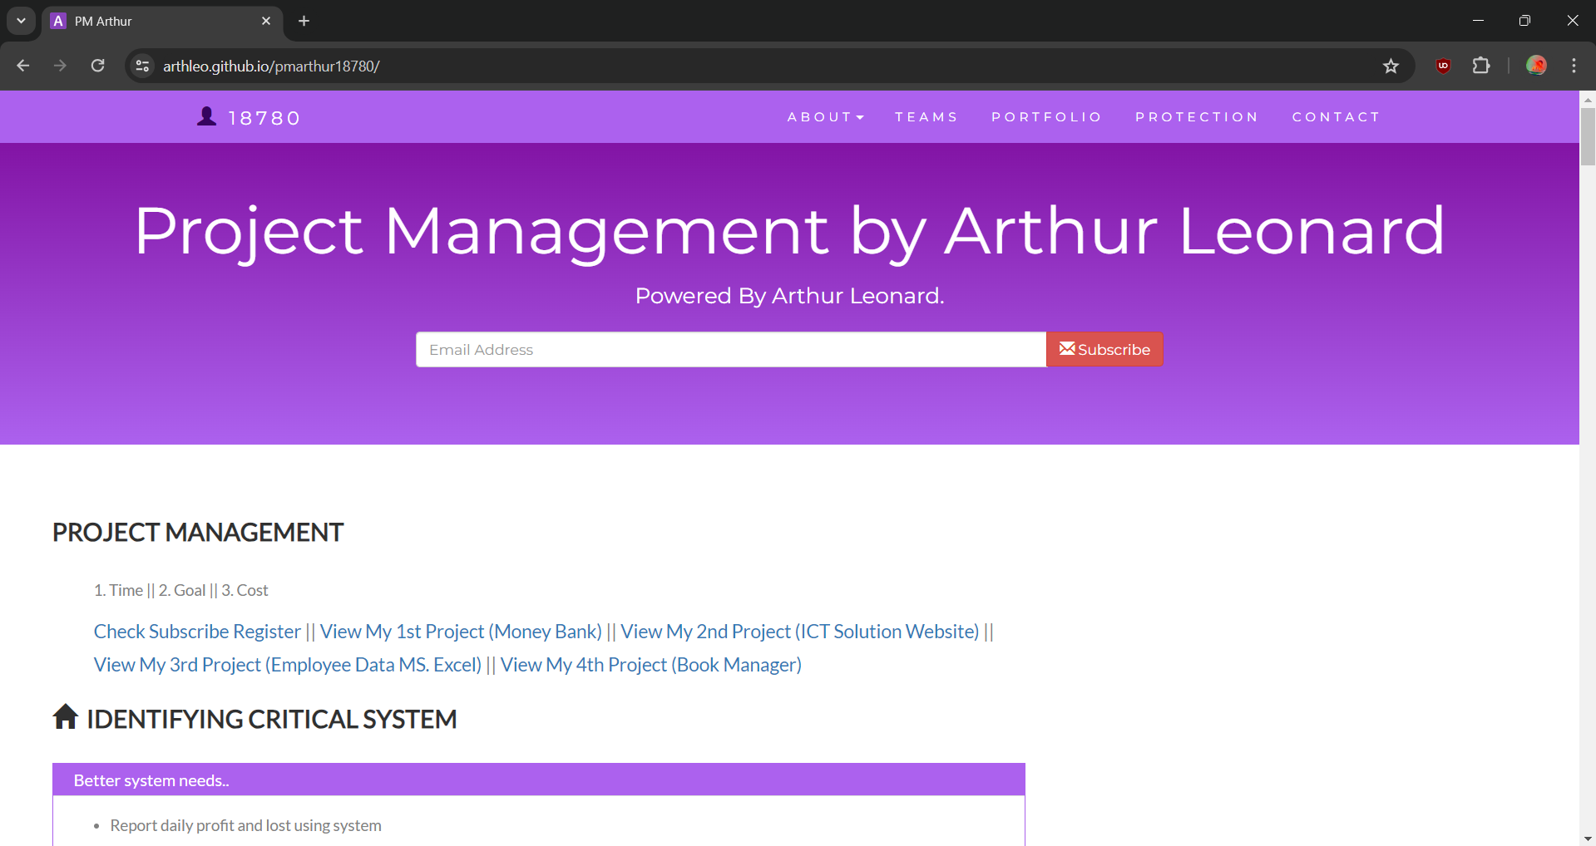

Please update below the contents about goal and cost

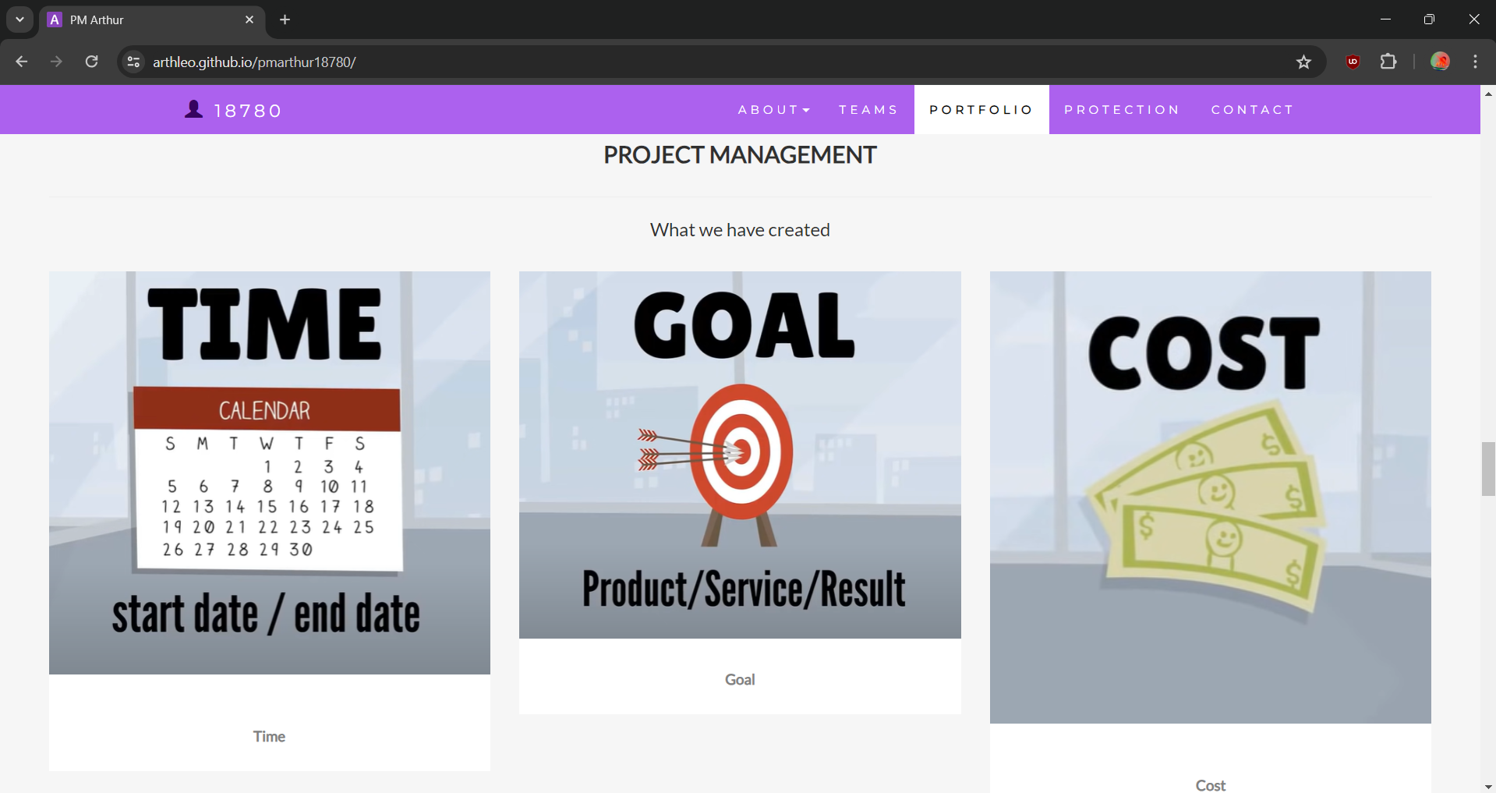

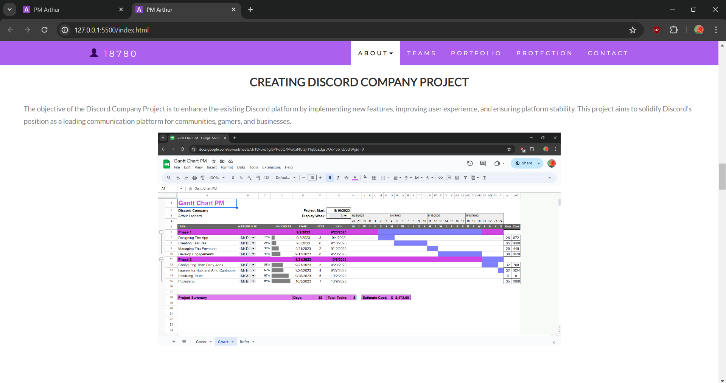

Refer to your current project, you have been asked to develop a project plan for WIC. Project plan outline as following:

**In my Discord Company Project, I designed following topics:**

* Introduction (Select one recommendation from Task 2 for implement project plan)

**(Please look on above my project charter)**

* Project background

**(Made Tasks and Plans)**

* **Related factor to organization**
* **Scope and objective of the project**
* **Information gathering plan and approach**
* **Gathering method, can be one of the following**

**Observation**

* **Project plan and schedule (Development and Maintenance)**
* **Work breakdown structure**
* **Gantt Chart**
* **Recourse and budget**

### Task 5: Project Closure

Prepare project closure document template as following:

* Project Sign-off document

When project sign off, it means your project finished. So you need make one clear sheet to tell everyone about your project. It will include:

* **Project Start Date: May 15, 2024**
* **Project Manager: Arthur Leonard**
* **Project Finish Date: July 30, 2024**
* **If something goes wrong, we could apply our plan B, which is:**
* **The objective of the Plan B for the Discord Company Project is to maintain and improve the current Discord platform with limited resources and time. This strategy aims to ensure continuity of service and address critical issues while minimizing costs.**

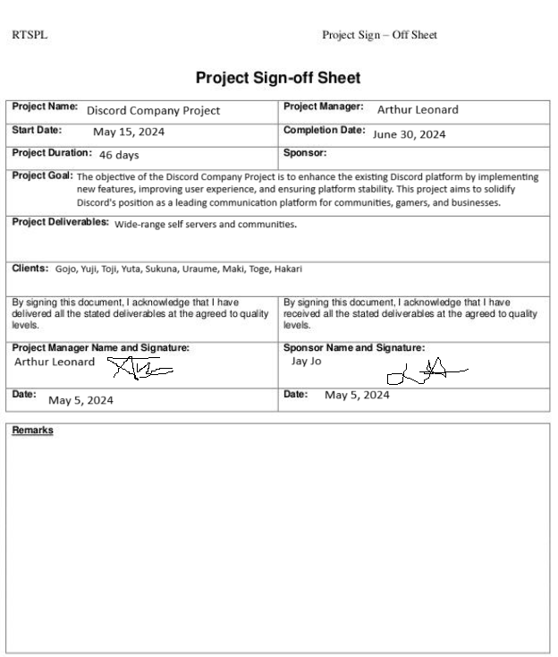

* Project evaluation document

You need to show your project, good or not enough. Summary all about your project

It may include:

1. **Budget Evaluation:**

* **Budget Allocation: The initial budget allocated for the project was $500,000. Actual expenditure amounted to $480,000, demonstrating effective cost management practices.**
* **Budget Utilization: Detailed tracking of expenses revealed that the majority of the budget was utilized for development and testing activities, with minimal overspending in certain areas due to unforeseen technical challenges.**
* **Budget Variance: The project team managed to maintain a variance of less than 5% between planned and actual expenditures, indicating a high level of budgetary control throughout the project lifecycle.**

1. **Quality Evaluation:**

* **Quality Assurance Processes: Rigorous testing procedures were implemented to ensure the quality and stability of the Discord platform. Continuous integration and automated testing helped identify and address issues promptly, resulting in a robust and reliable product.**
* **User Feedback: Regular solicitation of user feedback and engagement facilitated iterative improvements to the platform's features and user experience. Positive feedback from users indicated satisfaction with the quality of service provided.**
* **Bug Resolution: The project team demonstrated efficiency in resolving reported bugs and issues, maintaining a low bug density rate over the evaluation period. Critical bugs were prioritized and addressed promptly to minimize user impact.**

1. **Benefit Evaluation:**

* **User Adoption: Analysis of user metrics revealed a steady increase in user adoption and engagement since the implementation of new features and improvements. Key performance indicators such as active user count, session duration, and user retention rate showed positive trends over the evaluation period.**
* **Business Impact: The project's deliverables contributed to the company's strategic objectives by enhancing the platform's competitiveness and market position. Increased user satisfaction and retention translated into improved monetization opportunities and revenue growth.**
* **Operational Efficiency: Streamlined development processes and optimized resource utilization resulted in improved operational efficiency and productivity. Agile methodologies enabled the project team to adapt to changing requirements and deliver value to stakeholders in a timely manner.**

1. **Stakeholder Satisfaction:**

* **Internal Stakeholders: Feedback from internal stakeholders, including project team members and senior management, indicated overall satisfaction with the project's outcomes and the team's performance. Effective communication and collaboration fostered a positive working environment conducive to project success.**
* **External Stakeholders: External stakeholders, such as Discord users, investors, and business partners, expressed satisfaction with the platform's improvements and responsiveness to their needs. Transparent communication and responsiveness to feedback strengthened trust and loyalty among external stakeholders.**

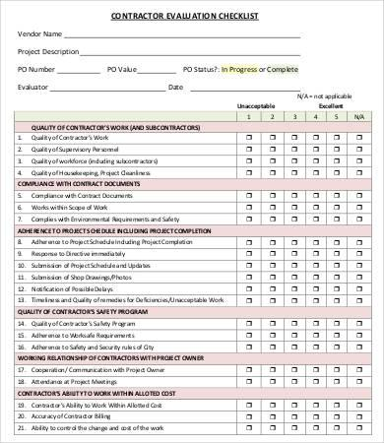

* Lesson learned template
* **What we have learn through this project**

1. **Importance of User Feedback: We learned that soliciting and incorporating user feedback is crucial for understanding user needs and preferences. Continuous engagement with users helped us prioritize features and improvements that directly impact user experience.**
2. **Agile Methodologies for Adaptability: Agile methodologies enabled us to adapt to changing requirements and deliver value iteratively. Embracing agile principles allowed us to respond quickly to challenges and incorporate feedback throughout the project lifecycle.**
3. **Effective Communication and Collaboration: Clear and transparent communication among project team members and stakeholders fostered collaboration and alignment towards common goals. Regular meetings, status updates, and feedback sessions facilitated a shared understanding of project objectives and priorities.**

* **Next Steps for Future Projects:**

1. **Comprehensive Project Planning: Prioritize comprehensive project planning to establish clear objectives, timelines, and resource requirements from the outset. Conduct thorough risk assessments and contingency planning to mitigate potential disruptions.**
2. **Stakeholder Engagement and Management: Proactively engage with stakeholders to gather input, manage expectations, and foster buy-in throughout the project lifecycle. Establish clear communication channels and feedback mechanisms to ensure stakeholders remain informed and involved.**
3. **Continuous Improvement and Learning: Encourage a culture of continuous improvement and learning within the project team. Conduct post-project reviews to identify areas for improvement and implement lessons learned in future projects.**

* **Lessons to Avoid Repeat Mistakes**

1. **Proactive Issue Identification and Resolution: Implement proactive measures to identify and address issues early in the project lifecycle, rather than waiting for them to escalate. Regular monitoring and communication can help prevent minor issues from becoming major setbacks.**
2. **Alignment of Stakeholder Expectations: Ensure alignment of stakeholder expectations with project objectives and deliverables from the outset. Clearly define roles, responsibilities, and success criteria to avoid misunderstandings and conflicts later in the project.**
3. **Flexibility in Project Planning: Maintain flexibility in project planning to accommodate changing requirements and priorities. Avoid rigid plans that do not allow for adjustments in response to evolving circumstances or stakeholder feedback.**

## Helpful web links to complete the assessment:

## Search Index

**B**

Benefit evaluation 10

Budget evaluation 10

**F**

feasible solution 1, 4

**P**

project sign off 9

**Q**

Quality evaluation 10

**S**

same mistake 10

scenario 1

specific focus 2